**Shark Tank India SQL Queries**

1. **Season Analysis**
2. **Number of Episodes Aired  
   Select season_number, count(Episode_Number) as Number_of_Episodes_Aired from `shark-tank-12.shark_tank_india.s-tank-india` group by Season_Number;**

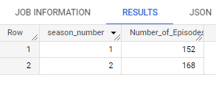

1. **No. of Unseen Pitches  
   Select season_number, count(Episode_Number) as Number_of_Unseen_Pitches from `shark-tank-12.shark_tank_india.s-tank-india` where Episode_Number = 0 group by Season_Number;**

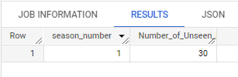

1. **No. of Presenters  
   3.1. Total  
   Select season_number, sum(Number_of_Presenters) as Total_No_of_Presenters from `shark-tank-12.shark_tank_india.s-tank-india` group by Season_Number;**

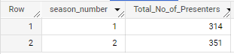

**3.2. Males  
Select season_number, sum(Number_of_Presenters) as Total_No_of_Male_Presenters from `shark-tank-12.shark_tank_india.s-tank-india` where Male_Presenters is not NULL group by Season_Number;**

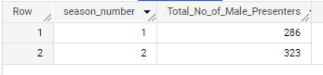

**3.3. Females  
Select season_number, sum(Number_of_Presenters) as Total_No_of_Female_Presenters from `shark-tank-12.shark_tank_india.s-tank-india` where Female_Presenters is not NULL group by Season_Number;**

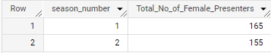

**3.4. Transgenders  
Select season_number, sum(Number_of_Presenters) as Total_No_of_Transgenders_Presenters from `shark-tank-12.shark_tank_india.s-tank-india` where Transgender_Presenters is not NULL group by Season_Number;**

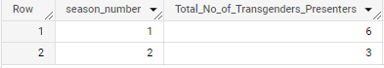

1. **Number of Couples Among Presenters  
   Select season_number, sum(Couple_Presenters) as Total_No_of_Couple_Presenters from `shark-tank-12.shark_tank_india.s-tank-india` group by Season_Number;**

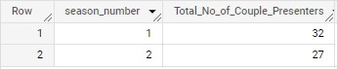

1. **Average No. of Team Members  
   Select season_number, round(avg(Number_of_Presenters),0) as Average_No_of_Team_Members from `shark-tank-12.shark_tank_india.s-tank-india` group by Season_Number;**

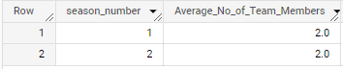

1. **Number of Presenters by Age Group**

**select Season_Number, Pitchers_Average_Age, count(Pitchers_Average_Age) as Number_of_Presenters from `shark-tank-12.shark_tank_india.s-tank-india` group by Pitchers_Average_Age, Season_Number order by Season_Number;**

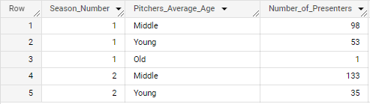

1. **Number of Pitches by State  
   select Season_Number, Pitchers_State, count(Pitchers_Average_Age) as Number_of_Pitches from `shark-tank-12.shark_tank_india.s-tank-india` group by Pitchers_State, Season_Number order by Season_Number;**

**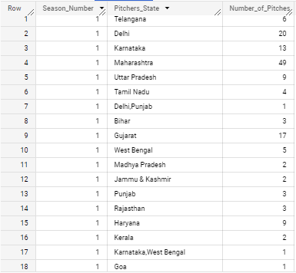  
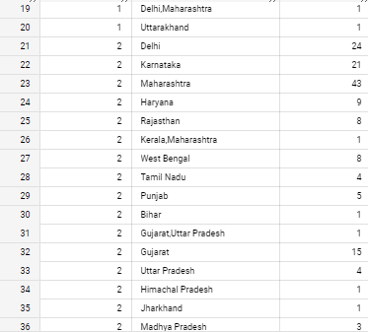  
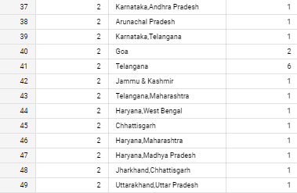**

1. **No. of Pitches  
   a. Total  
   select Season_Number, count(Pitch_Number) as Number_Of_Pitches from `shark-tank-12.shark_tank_india.s-tank-india` group by Season_Number;**

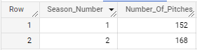

**b. Offered  
select Season_Number, count(Pitch_Number) as Number_Of_Pitches_with_Offer from `shark-tank-12.shark_tank_india.s-tank-india` where Received_Offer =1 group by Season_Number;**

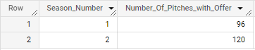

**c. Unoffered  
select Season_Number, count(Pitch_Number) as Number_Of_Pitches_with_Offer from `shark-tank-12.shark_tank_india.s-tank-india` where Received_Offer =0 group by Season_Number;**

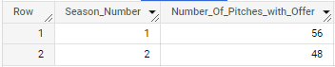

1. **Offers  
   a. Total  
   select Season_Number, count(Pitch_Number) as Total_Number_Of_Offer from `shark-tank-12.shark_tank_india.s-tank-india` where Received_Offer =1 group by Season_Number;**

**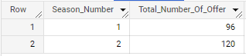  
b. Accepted  
select Season_Number, count(Pitch_Number) as Number_Of_Accepted_Offers from `shark-tank-12.shark_tank_india.s-tank-india` where Accepted_Offer =1 group by Season_Number;**

**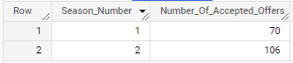  
c. Rejected  
select Season_Number, count(Pitch_Number) as Number_Of_Rejected_Offers from `shark-tank-12.shark_tank_india.s-tank-india` where Accepted_Offer =0 group by Season_Number;**

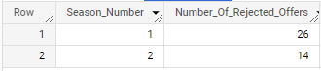

1. **Patents  
   a. Involved**

**select Season_Number, count(Pitch_Number) as Number_Of_Deals_with_Patents from `shark-tank-12.shark_tank_india.s-tank-india` where Has_Patents =1 group by Season_Number;**

**  
b. Not Involved  
select Season_Number, count(Pitch_Number) as Number_Of_Deals_with_Patents from `shark-tank-12.shark_tank_india.s-tank-india` where Has_Patents =0 group by Season_Number;**

1. **Deals Involving all Sharks  
   select Season_Number, count(Pitch_Number) as Number_Of_Deals_With_All_Sharks from `shark-tank-12.shark_tank_india.s-tank-india` where Number_of_sharks_in_deal=5 group by Season_Number;**

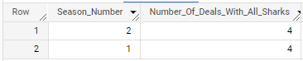

1. **Highest Equity Taken by Sharks  
   select Season_Number, max(total_deal_Equity) as Maximum_Equity_Taken_By_Sharks from`shark-tank-12.shark_tank_india.s-tank-india` group by Season_Number;**

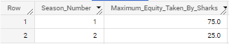

1. **Debt Offers  
   a. Total  
   SELECT Season_Number, count(Pitch_Number) as Number_of_Pitches_With_Debt from `shark-tank-12.shark_tank_india.s-tank-india` where Total_Deal_Debt is not null group by Season_Number;  
     
   b. With Interest  
   SELECT Season_Number, count(Pitch_Number) as Number_of_Pitches_With_Debt_Int from `shark-tank-12.shark_tank_india.s-tank-india` where Debt_Interest is not null group by Season_Number;**

**  
c. Without Interest  
SELECT Season_Number, count(Pitch_Number) as Number_of_Pitches_Without_Debt_Int from `shark-tank-12.shark_tank_india.s-tank-india` where Debt_Interest is null group by Season_Number;**

**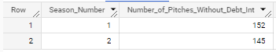  
d. Highest Interest Rate  
SELECT Season_Number, max(Debt_Interest) as Highest_Debt_Int from `shark-tank-12.shark_tank_india.s-tank-india` group by Season_Number;**

**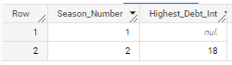  
e. Lowest Interest Rate  
SELECT Season_Number, min(Debt_Interest) as Lowest_Debt_Int from `shark-tank-12.shark_tank_india.s-tank-india` group by Season_Number;**

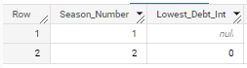

1. **Annual Revenue  
   a. Average Annual Revenue  
   SELECT Season_Number, round(avg(Yearly_Revenue),2) as Average_Annual_Revenue_in_Lakhs from `shark-tank-12.shark_tank_india.s-tank-india` group by Season_Number;**

**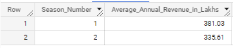  
b. Maximum Annual Revenue  
SELECT Season_Number, round(max(Yearly_Revenue),2) as Maximum_Annual_Revenue_in_Lakhs from `shark-tank-12.shark_tank_india.s-tank-india` group by Season_Number;**

**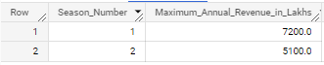  
c. Minimum Annual Revenue  
SELECT Season_Number, round(min(Yearly_Revenue),2) as Minimum_Annual_Revenue_in_Lakhs from `shark-tank-12.shark_tank_india.s-tank-india` group by Season_Number;**

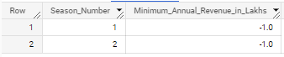

1. **Monthly Sales  
   a. Average Monthly sales  
   SELECT Season_Number, round(avg(Monthly_Sales),2) as Average_Monthly_Sales_in_Lakhs from `shark-tank-12.shark_tank_india.s-tank-india` group by Season_Number;**

**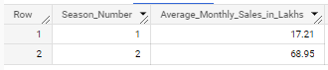  
b. MaximMonthly sales  
SELECT Season_Number, round(max(Monthly_Sales),2) as Maximum_Monthly_Sales_in_Lakhs from `shark-tank-12.shark_tank_india.s-tank-india` group by Season_Number;**

**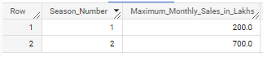  
c. Minimum Monthly sales  
SELECT Season_Number, round(min(Monthly_Sales),2) as Minimum_Monthly_Sales_in_Lakhs from `shark-tank-12.shark_tank_india.s-tank-india` where Monthly_Sales>0 group by Season_Number;**

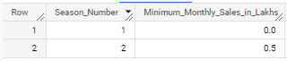

1. **Gross Margin  
   a. Average Gross Margin  
   SELECT Season_Number, round(avg(Gross_Margin),2) as Average_Gross_Margin_in_Lakhs from `shark-tank-12.shark_tank_india.s-tank-india` group by Season_Number;**

**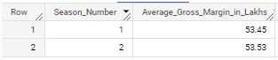  
b. Maximum Gross Margin  
SELECT Season_Number, round(max(Gross_Margin),2) as Maximum_Gross_margin_in_Lakhs from `shark-tank-12.shark_tank_india.s-tank-india` group by Season_Number;**

**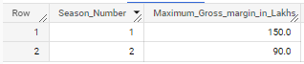  
c. Minimum Gross Margin  
SELECT Season_Number, round(min(Gross_Margin),2) as Minimum_Gross_Margin_in_Lakhs from `shark-tank-12.shark_tank_india.s-tank-india` where Gross_Margin>0 group by Season_Number;**

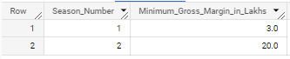

1. **Business Starting Year  
   a. Earliest  
   SELECT Season_Number, max(Started_in) as Earliset_Business_Starting_Year from `shark-tank-12.shark_tank_india.s-tank-india` group by Season_Number;**

**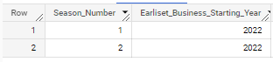  
b. Latest  
SELECT Season_Number, min(Started_in) as Latest_Business_Starting_Year from `shark-tank-12.shark_tank_india.s-tank-india` group by Season_Number;**

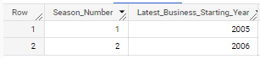

1. **Valuation Requested  
   a. Average Valuation Requested  
   SELECT Season_Number, round(avg(Valuation_Requested),2) as Average_valuation_Requested_in_Lakhs from `shark-tank-12.shark_tank_india.s-tank-india` group by Season_Number;**

**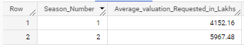  
b. Maximum Valuation Requested  
SELECT Season_Number, round(max(Valuation_Requested),2) as Maximum_valuation_Requested_in_Lakhs from `shark-tank-12.shark_tank_india.s-tank-india` group by Season_Number;**

**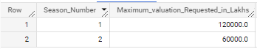  
c. Minimum Valuation Requested  
SELECT Season_Number, round(min(Valuation_Requested),2) as Minimum_valuation_Requested_in_Lakhs from `shark-tank-12.shark_tank_india.s-tank-india` where Valuation_Requested>0 group by Season_Number;**

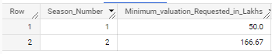

1. **Deal Valuation   
   a. Average Deal Valuation**

**SELECT Season_Number, round(avg(Deal_Valuation),2) as Average_Deal_Valuation_in_Lakhs from `shark-tank-12.shark_tank_india.s-tank-india` group by Season_Number;**

**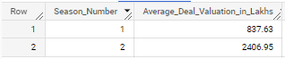  
b. Maximum Deal Valuation   
SELECT Season_Number, round(max(Deal_Valuation),2) as Maximum_Deal_Valuation_in_Lakhs from `shark-tank-12.shark_tank_india.s-tank-india` group by Season_Number;**

**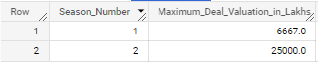  
c. Minimum Deal Valuation   
SELECT Season_Number, round(min(Deal_Valuation),2) as Minimum_Deal_Valuation_in_Lakhs from `shark-tank-12.shark_tank_india.s-tank-india` where Deal_Valuation>0 group by Season_Number;**

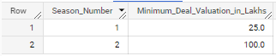

1. **Deal Amount  
   a. Average Deal Amount  
   SELECT Season_Number, round(avg(Total_Deal_Amount),2) as Average_Deal_Amount_in_Lakhs from `shark-tank-12.shark_tank_india.s-tank-india` group by Season_Number;**

**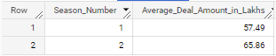  
b. Maximum Deal Amount  
SELECT Season_Number, round(max(Total_Deal_Amount),2) as Maximum_Deal_Amount_in_Lakhs from `shark-tank-12.shark_tank_india.s-tank-india` group by Season_Number;**

**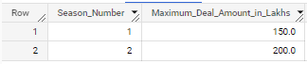  
c. Minimum Deal Amount  
SELECT Season_Number, round(min(Total_Deal_Amount),2) as Minimum_Deal_Amount_in_Lakhs from `shark-tank-12.shark_tank_india.s-tank-india` where Total_Deal_Amount>0 group by Season_Number;**

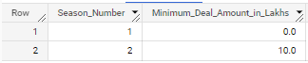

1. **Original Ask Amount  
   a. Average Original Ask Amount  
   SELECT Season_Number, round(avg(Original_Ask_Amount),2) as Average_Ask_Amount_in_Lakhs from `shark-tank-12.shark_tank_india.s-tank-india` group by Season_Number;**

**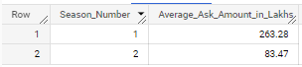  
b. Maximum Original Ask Amount  
SELECT Season_Number, round(max(Original_Ask_Amount),2) as Maximum_Ask_Amount_in_Lakhs from `shark-tank-12.shark_tank_india.s-tank-india` group by Season_Number;**

**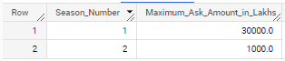  
c. Minimum Original Ask Amount  
SELECT Season_Number, round(min(Original_Ask_Amount),2) as Minimum_Ask_Amount_in_Lakhs from `shark-tank-12.shark_tank_india.s-tank-india` where Original_Ask_Amount>0 group by Season_Number;**

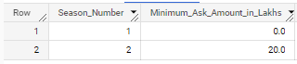

1. **Valuation Difference  
   a. Average Valuation Difference  
   SELECT Season_Number, round(avg(Deal_Valuation-Valuation_Requested),2) as Average_Valuation_Difference_in_Lakhs from `shark-tank-12.shark_tank_india.s-tank-india` group by Season_Number;**

**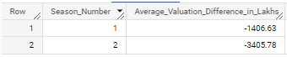  
b. Maximum Valuation Difference  
SELECT Season_Number, round(min(Deal_Valuation-Valuation_Requested),2) as Maximum_Valuation_Difference_in_Lakhs from `shark-tank-12.shark_tank_india.s-tank-india` group by Season_Number;**

**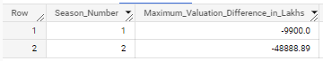  
c. Minimum Valuation Difference  
SELECT Season_Number, round(max(Deal_Valuation-Valuation_Requested),2) as Minimum_Valuation_Difference_in_Lakhs from `shark-tank-12.shark_tank_india.s-tank-india` group by Season_Number;**

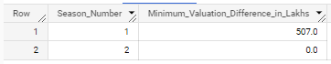

**B. Shark Specific Analysis**

1. **Ashneer Grover  
   a. Total No. of Deals  
   SELECT Season_Number, count(Ashneer_Investment_Amount) as Number_Of_Deals_Ashneer_Invested_in from `shark-tank-12.shark_tank_india.s-tank-india` group by Season_Number;**

**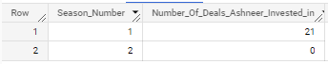  
b. Total Amount Invested**

**SELECT Season_Number, round(sum(Ashneer_Investment_Amount),2) as Ashneer_Total_Investment from `shark-tank-12.shark_tank_india.s-tank-india` group by Season_Number;**

**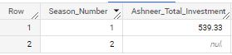  
c. Total Debt  
SELECT Season_Number, round(sum(Ashneer_Debt_Amount),2) as Ashneer_Total_Debt from `shark-tank-12.shark_tank_india.s-tank-india` group by Season_Number;**

**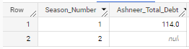  
d. Minimum Equity Taken**

**SELECT Season_Number, min(Ashneer_Investment_Equity) as Ashneer_Minimum_Equity from `shark-tank-12.shark_tank_india.s-tank-india` group by Season_Number;**

**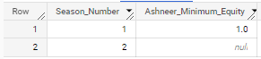  
e. Maximum Equity Taken  
SELECT Season_Number, max(Ashneer_Investment_Equity) as Ashneer_Maximum_Equity from `shark-tank-12.shark_tank_india.s-tank-india` group by Season_Number;**

**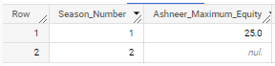  
f. Deal with Maximum Investment  
SELECT Season_Number,Startup_Name, Industry,Ashneer_Investment_Amount from `shark-tank-12.shark_tank_india.s-tank-india` where Ashneer_Investment_Amount is not null order by Ashneer_Investment_Amount desc limit 1;**

**  
g. Deal with Minimum Investment  
SELECT Season_Number,Startup_Name, Industry,Ashneer_Investment_Amount from `shark-tank-12.shark_tank_india.s-tank-india` where Ashneer_Investment_Amount is not null order by Ashneer_Investment_Amount limit 1;**



1. **Namita Thapar  
   a. Total No. of Deals  
    SELECT Season_Number, count(Namita_Investment_Amount) as Number_Of_Deals_Namita_Invested_in from `shark-tank-12.shark_tank_india.s-tank-india` group by Season_Number;**

**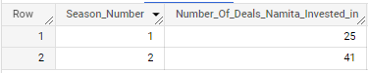  
b. Total Amount Invested  
SELECT Season_Number, round(sum(Namita_Investment_Amount),2) as Namita_Total_Investment from `shark-tank-12.shark_tank_india.s-tank-india` group by Season_Number;**

**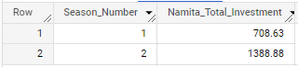  
c. Total Debt  
SELECT Season_Number, round(sum(Namita_Debt_Amount),2) as Namita_Total_Debt from `shark-tank-12.shark_tank_india.s-tank-india` group by Season_Number;**

**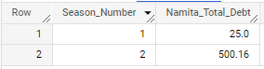  
d. Minimum Equity Taken  
SELECT Season_Number, min(Namita_Investment_Equity) as Namita_Minimum_Equity from `shark-tank-12.shark_tank_india.s-tank-india` group by Season_Number;**

**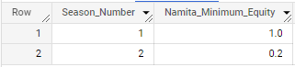  
e. Maximum Equity Taken  
SELECT Season_Number, max(Namita_Investment_Equity) as Namita_Maximum_Equity from `shark-tank-12.shark_tank_india.s-tank-india` group by Season_Number;**

**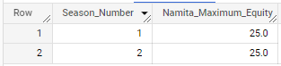  
f. Deal with Maximum Investment  
SELECT Season_Number,Startup_Name, Industry,Namita_Investment_Amount from `shark-tank-12.shark_tank_india.s-tank-india` where Namita_Investment_Amount is not null order by Namita_Investment_Amount desc limit 1;**

**  
g. Deal with Minimum Investment  
SELECT Season_Number,Startup_Name, Industry,Namita_Investment_Amount from `shark-tank-12.shark_tank_india.s-tank-india` where Namita_Investment_Amount is not null order by Namita_Investment_Amount limit 1;**



1. **Anupam Mittal  
   a. Total No. of Deals  
   SELECT Season_Number, count(Anupam_Investment_Amount) as Number_Of_Deals_Anupam_Invested_in from `shark-tank-12.shark_tank_india.s-tank-india` group by Season_Number;**

**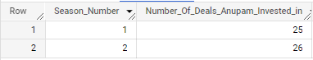  
b. Total Amount Invested  
SELECT Season_Number, round(sum(Anupam_Investment_Amount),2) as Anupam_Total_Investment from `shark-tank-12.shark_tank_india.s-tank-india` group by Season_Number;**

**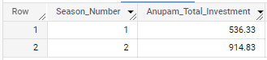  
c. Total Debt  
SELECT Season_Number, round(sum(Anupam_Investment_Amount),2) as Anupam_Total_Debt from `shark-tank-12.shark_tank_india.s-tank-india` group by Season_Number;**

**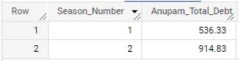  
d. Minimum Equity Taken  
SELECT Season_Number, min(Anupam_Investment_Equity) as Anupam_Minimum_Equity from `shark-tank-12.shark_tank_india.s-tank-india` group by Season_Number;**

**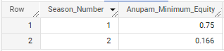  
e. Maximum Equity Taken  
SELECT Season_Number, max(Anupam_Investment_Equity) as Anupam_Maximum_Equity from `shark-tank-12.shark_tank_india.s-tank-india` group by Season_Number;**

**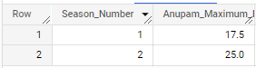  
f. Deal with Maximum Investment  
SELECT Season_Number,Startup_Name, Industry,Anupam_Investment_Amount from `shark-tank-12.shark_tank_india.s-tank-india` where Anupam_Investment_Amount is not null order by Anupam_Investment_Amount desc limit 1;**



**g. Deal with Minimum Investment  
SELECT Season_Number,Startup_Name, Industry,Anupam_Investment_Amount from `shark-tank-12.shark_tank_india.s-tank-india` where Anupam_Investment_Amount is not null order by Anupam_Investment_Amount limit 1;**



1. **Ghazal Alagh  
   a. Total No. of Deals  
    SELECT Season_Number, count(Ghazal_Investment_Amount) as Number_Of_Deals_Ghazal_Invested_in from `shark-tank-12.shark_tank_india.s-tank-india` group by Season_Number;**

**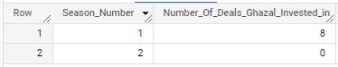  
b. Total Amount Invested  
SELECT Season_Number, round(sum(Ghazal_Investment_Amount),2) as Ghazal_Total_Investment from `shark-tank-12.shark_tank_india.s-tank-india` group by Season_Number;**

**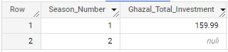  
d. Minimum Equity Taken  
SELECT Season_Number, min(Ghazal_Investment_Equity) as Ghazal_Minimum_Equity from `shark-tank-12.shark_tank_india.s-tank-india` group by Season_Number;**

**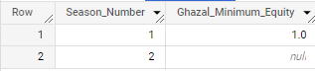  
e. Maximum Equity Taken  
SELECT Season_Number, max(Ghazal_Investment_Equity) as Ghazal_Maximum_Equity from `shark-tank-12.shark_tank_india.s-tank-india` group by Season_Number;**

**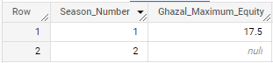  
f. Deal with Maximum Investment  
SELECT Season_Number,Startup_Name, Industry,Ghazal_Investment_Amount from `shark-tank-12.shark_tank_india.s-tank-india` where Ghazal_Investment_Amount is not null order by Ghazal_Investment_Amount desc limit 1;**

**  
g. Deal with Minimum Investment  
SELECT Season_Number,Startup_Name, Industry,Ghazal_Investment_Amount from `shark-tank-12.shark_tank_india.s-tank-india` where Ghazal_Investment_Amount is not null order by Ghazal_Investment_Amount limit 1;**



1. **Peyush Bansal  
   a. Total No. of Deals  
   SELECT Season_Number, count(Peyush_Investment_Amount) as Number_Of_Deals_Peyush_Invested_in from `shark-tank-12.shark_tank_india.s-tank-india` group by Season_Number;**

**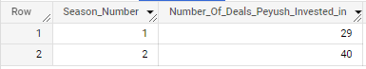  
b. Total Amount Invested  
SELECT Season_Number, round(sum(Peyush_Investment_Amount),2) as Peyush_Total_Investment from `shark-tank-12.shark_tank_india.s-tank-india` group by Season_Number;**

**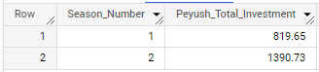  
c. Total Debt  
SELECT Season_Number, round(sum(Peyush_Debt_Amount),2) as Peyush_Total_Debt from `shark-tank-12.shark_tank_india.s-tank-india` group by Season_Number;**

**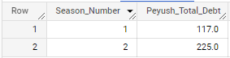  
d. Minimum Equity Taken  
SELECT Season_Number, min(Peyush_Investment_Equity) as Peyush_Minimum_Equity from `shark-tank-12.shark_tank_india.s-tank-india` group by Season_Number;**

**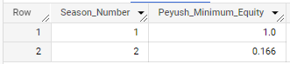  
e. Maximum Equity Taken**

**SELECT Season_Number, max(Peyush_Investment_Equity) as Peyush_Maximum_Equity from `shark-tank-12.shark_tank_india.s-tank-india` group by Season_Number;**

**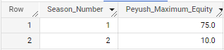  
f. Deal with Maximum Investment**

**SELECT Season_Number,Startup_Name, Industry,Peyush_Investment_Amount from `shark-tank-12.shark_tank_india.s-tank-india` where Peyush_Investment_Amount is not null order by Peyush_Investment_Amount desc limit 1;**

**  
g. Deal with Minimum Investment  
SELECT Season_Number,Startup_Name, Industry,Peyush_Investment_Amount from `shark-tank-12.shark_tank_india.s-tank-india` where Peyush_Investment_Amount is not null order by Peyush_Investment_Amount limit 1;**



1. **Vineeta Singh  
   a. Total No. of Deals  
   SELECT Season_Number, count(Vineeta_Investment_Amount) as Number_Of_Deals_Vineeta_Invested_in from `shark-tank-12.shark_tank_india.s-tank-india` group by Season_Number;**

**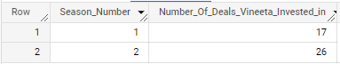  
b. Total Amount Invested  
SELECT Season_Number, round(sum(Vineeta_Investment_Amount),2) as Vineeta_Total_Investment from `shark-tank-12.shark_tank_india.s-tank-india` group by Season_Number;**

**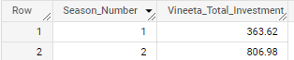  
c. Total Debt**

**SELECT Season_Number, round(sum(Vineeta_Debt_Amount),2) as Vineeta_Total_Debt from `shark-tank-12.shark_tank_india.s-tank-india` group by Season_Number;**

**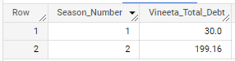  
d. Minimum Equity Taken**

**SELECT Season_Number, min(Vineeta_Investment_Equity) as Vineeta_Minimum_Equity from `shark-tank-12.shark_tank_india.s-tank-india` group by Season_Number;**

**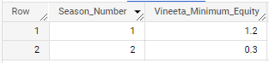  
e. Maximum Equity Taken**

**SELECT Season_Number, max(Vineeta_Investment_Equity) as Vineeta_Maximum_Equity from `shark-tank-12.shark_tank_india.s-tank-india` group by Season_Number;**

**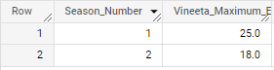  
f. Deal with Maximum Investment**

**SELECT Season_Number,Startup_Name, Industry,Vineeta_Investment_Amount from `shark-tank-12.shark_tank_india.s-tank-india` where Vineeta_Investment_Amount is not null order by Vineeta_Investment_Amount desc limit 1;**

**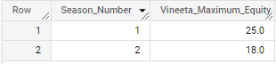  
g. Deal with Minimum Investment**

**SELECT Season_Number,Startup_Name, Industry,Vineeta_Investment_Amount from `shark-tank-12.shark_tank_india.s-tank-india` where Vineeta_Investment_Amount is not null order by Vineeta_Investment_Amount limit 1;**



1. **Aman Gupta  
   a. Total No. of Deals**

**SELECT Season_Number, count(Aman_Investment_Amount) as Number_Of_Deals_Aman_Invested_in from `shark-tank-12.shark_tank_india.s-tank-india` group by Season_Number;**

**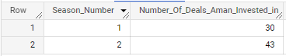  
b. Total Amount Invested**

**SELECT Season_Number, round(sum(Aman_Investment_Amount),2) as Aman_Total_Investment from `shark-tank-12.shark_tank_india.s-tank-india` group by Season_Number;**

**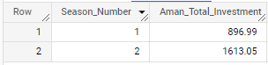  
c. Total Debt**

**SELECT Season_Number, round(sum(Aman_Debt_Amount),2) as Aman_Total_Debt from `shark-tank-12.shark_tank_india.s-tank-india` group by Season_Number;**

**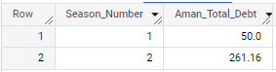  
d. Minimum Equity Taken**

**SELECT Season_Number, min(Aman_Investment_Equity) as Aman_Minimum_Equity from `shark-tank-12.shark_tank_india.s-tank-india` group by Season_Number;**

**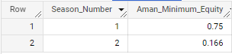  
e. Maximum Equity Taken**

**SELECT Season_Number, max(Aman_Investment_Equity) as Aman_Maximum_Equity from `shark-tank-12.shark_tank_india.s-tank-india` group by Season_Number;**

**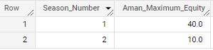  
f. Deal with Maximum Investment**

**SELECT Season_Number,Startup_Name, Industry,Aman_Investment_Amount from `shark-tank-12.shark_tank_india.s-tank-india` where Aman_Investment_Amount is not null order by Aman_Investment_Amount desc limit 1;**

**  
g. Deal with Minimum Investment**

**SELECT Season_Number,Startup_Name, Industry,Aman_Investment_Amount from `shark-tank-12.shark_tank_india.s-tank-india` where Aman_Investment_Amount is not null order by Aman_Investment_Amount limit 1;**



1. **Amit Jain  
   a. Total No. of Deals**

**SELECT Season_Number, count(Amit_Investment_Amount) as Number_Of_Deals_Amit_Invested_in from `shark-tank-12.shark_tank_india.s-tank-india` group by Season_Number;**

**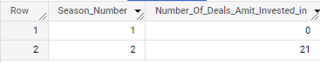  
b. Total Amount Invested**

**SELECT Season_Number, round(sum(Amit_Investment_Amount),2) as Amit_Total_Investment from `shark-tank-12.shark_tank_india.s-tank-india` group by Season_Number;**

**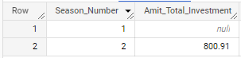  
c. Total Debt**

**SELECT Season_Number, round(sum(Amit_Debt_Amount),2) as Amit_Total_Debt from `shark-tank-12.shark_tank_india.s-tank-india` group by Season_Number;**

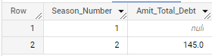

**d. Minimum Equity Taken**

**SELECT Season_Number, min(Amit_Investment_Equity) as Amit_Minimum_Equity from `shark-tank-12.shark_tank_india.s-tank-india` group by Season_Number;**

**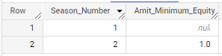  
e. Maximum Equity Taken**

**SELECT Season_Number, max(Amit_Investment_Equity) as Amit_Maximum_Equity from `shark-tank-12.shark_tank_india.s-tank-india` group by Season_Number;**

**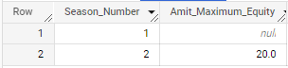  
f. Deal with Maximum Investment**

**SELECT Season_Number,Startup_Name, Industry,Amit_Investment_Amount from `shark-tank-12.shark_tank_india.s-tank-india` where Amit_Investment_Amount is not null order by Amit_Investment_Amount desc limit 1;**

**  
g. Deal with Minimum Investment**

**SELECT Season_Number,Startup_Name, Industry,Amit_Investment_Amount from `shark-tank-12.shark_tank_india.s-tank-india` where Amit_Investment_Amount is not null order by Amit_Investment_Amount limit 1;**



1. **Vikas (Guest)  
   a. Total No. of Deals**

**SELECT Season_Number, count(Guest_Investment_Amount) as Number_Of_Deals_Guest_Invested_in from `shark-tank-12.shark_tank_india.s-tank-india` group by Season_Number;**

**`shark-tank-12.shark_tank_india.s-tank-india` group by Season_Number;**

**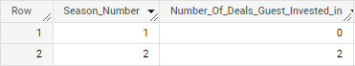  
b. Total Amount Invested**

**SELECT Season_Number, round(sum(Guest_Investment_Amount),2) as Guest_Total_Investment from `shark-tank-12.shark_tank_india.s-tank-india` group by Season_Number;**

**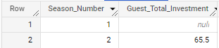  
c. Total Debt**

**SELECT Season_Number, round(sum(Guest_Debt_Amount),2) as Guest_Total_Debt from `shark-tank-12.shark_tank_india.s-tank-india` group by Season_Number;**

**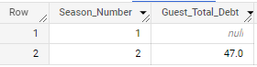  
d. Minimum Equity Taken**

**SELECT Season_Number, min(Guest_Investment_Equity) as Guest_Minimum_Equity from `shark-tank-12.shark_tank_india.s-tank-india` group by Season_Number;**

**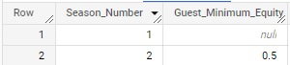  
e. Maximum Equity Taken**

**SELECT Season_Number, max(Guest_Investment_Equity) as Guest_Maximum_Equity from `shark-tank-12.shark_tank_india.s-tank-india` group by Season_Number;**

**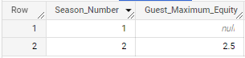  
f. Deal with Maximum Investment**

**SELECT Season_Number,Startup_Name, Industry,Guest_Investment_Amount from `shark-tank-12.shark_tank_india.s-tank-india` where Guest_Investment_Amount is not null order by Guest_Investment_Amount desc limit 1;**

**  
g. Deal with Minimum Investment**

**SELECT Season_Number,Startup_Name, Industry,Guest_Investment_Amount from `shark-tank-12.shark_tank_india.s-tank-india` where Guest_Investment_Amount is not null order by Guest_Investment_Amount limit 1;**

